Individual Project
Title:
Can we accurately classify whether an employee will leave the company using machine learning models?

Jasraj Singh Chhokar 24061519
jsc53

- Introduction

This report explores employee attrition using the Final Dataset Attrition.csv, which contains a range of demographic, behavioural and job-related variables which include employee characteristics such as age, monthly income, number of companies previously worked for, job satisfaction, year at the company and many more, along with employment outcomes represented as binary attrition status in the form of (“Yes” or “No”). The objective of this analysis is to determine whether machine-learning algorithms can be used to classify employee attrition with meaningful accuracy and to identify the most important predictors.

Overall, this report aims to answer the question:
“Can we accurately classify whether an employee will leave the company using machine learning models?”
By comparing the performance of traditional statistical methods with advanced machine-learning and deep-learning techniques, this analysis provides insights into how feasible the automated attrition prediction is and also highlights the factors most strongly associated with employee attrition.

- Methodology

In this analysis, I have applied and used a multi-model, machine-learning framework to investigate employee attrition using the dataset. The overall goal of the methodology is to determine whether employee attrition can be predicted accurately and to evaluate the performance of multiple classification models under consistent conditions.

The analysis is conducted through different stages which include data preparation, exploratory modelling, supervised machine learning, model evaluation and comparative performance analysis, using the following key techniques:

- Data Preparation and Exploratory Modelling

Data Ingestion and Cleaning:
I have imported the dataset using read.csv(), then I converted the target variable Attrition into a binary factor using as.factor() and relevel(). I verified the dataset using str() and checked the class balance using table() and I made additional variables which can be used to support the logistic modelling and visualisation.

GLM Residual Modelling:
I fit an initial logistic regression model to see the baseline linear relationships between the predictors and attrition. Once I did this, I extracted the fitted values and deviance residuals to evaluate the potential nonlinearity or model misfit. Then I visualised a residual pattern using a Residual vs Fitted plot using geom_point() and geom_smooth() which helps check for bias, overdispersion or non linear effects on the data.

Exploratory Predictor:
First, I generated predicted probability curves for individual predictors that had the most effect on employee attrition like Age, Monthly Income, Distance From Home and Total Working Years using new data grids and predict(). I used ggplot2 to create smoothed logistic curves and overlays to allow for interpretation of how each variable influences attrition probability individually.

- Supervised Learning Models

To classify employee attrition, I have implemented 4 supervised machine learning models:

Logistic Regression(GLM):
I have used this model to provide a transparent, interpretable baseline model which can be used for binary classification and this model also acts as a comparison point for more complex models. To fit the model, I used train(method = “glm”) and included multiple predictors from the dataset and then evaluated this using a repeated cross-validation trainControl() to improve the reliability of the model.

Random Forest Classification:
I used random forest classification to capture nonlinear relationships and interactions that GLM is not able to model explicitly. I built the model using train(method = “rf”) with repeated cross-validation which includes key predictors such as Job Satisfaction, Number of Companies Worked, Overtime and Years with Current Manager. I also computed variable importance using varImp() and visualised the variables importance with the use of ggplot2. Random Forest was used as it is robust to noise and handles mixed variable types and is able to perform on prediction tasks due to its ability to model complex tree-based patterns.

XGBoost:
I used the XGBoost model to provide a high-performance boosting-based classifier that handles nonlinear relationships, sparsity and interaction effects efficiently. I trained the model using train(method = “xgbTree”) and then tuned through cross-validation to optimise ROC-based performance and I also used the same predictor set as the other models for a fair comparison. XGBoost was used as it is recognised for its superior predictive accuracy in structured tabular data which makes it suitable for sensitive classification problems such as this employee attrition prediction.

Deep Learning:
Deep Learning models highly nonlinear relationships using a multi-layer neural network capable of capturing subtle interactions across predictors. To implement this, I had to construct a 3-layer neural network with ReLU activations and dropout regularisation and then converted training and testing data to model matrices using model.matrix(). Then I had scaled all the numeric predictors for neural network convergence and trained it using keras_model_sequential() and then I had evaluated predictions on the test set with ROC and confusionMatrix. Deep Learning was used as it offers an advanced pattern-recognition capability and provides a highly flexible model which allows for comparisons to machine learning techniques

- Model Evaluation and Comparison

Each model was assessed using a consistent test data with the following techniques to evaluate them:

- Confusion Matrix: to measure accuracy, sensitivity and prediction errors
- ROC Curve and AUC: this is to evaluate classification discrimination power across all classification models
- Model Comparison Table: this compiled AUC valued for GLM, Random Forest, XGBoost and Deep Learning into an ordered summary.

This framework provides a fair and transparent comparison between statistical methods and machine learning techniques.

- Technical Implementation

In this analysis, the following R packages were used:

- Tidyverse: used for Data preparation and visualisation
- Caret: used for cross-validation, model-tuning and machine learning interface
- randomForest and xgboost: packages needed for specialised machine algorithms to function
- Keras: used for the construction and training of deep neural networks
- pROC: used for the generation of ROC curve and AUC computation

- Results
Figure 1:
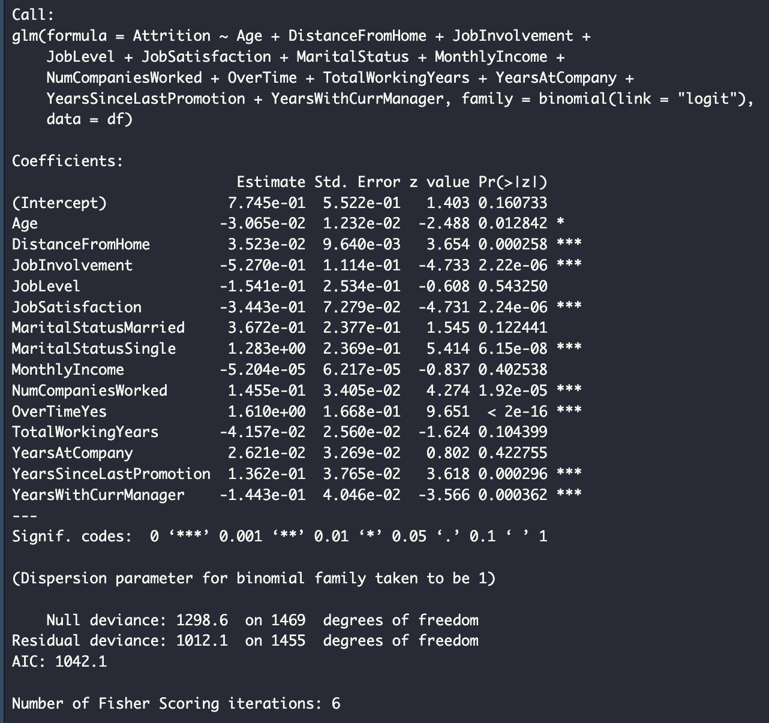
In this figure, we can see the fitting of a logistic regression model using different predictor variables to estimate the log-odds of attrition for each predictor and we print a summary of all coefficient estimates, significance levels, deviance, AIC and more
Important predictors such as Age tell us that older employees are less likely to leave and younger employees are more likely to leave due to the estimated value being negative which means it has less influence on attrition and this is the case for other factors like Years with Current Manager and JobInvolvement. However, compared to OverTime which is the strongest positive predictor which tells us that employees working overtime are much more likely to quit their job and other factors that also influence and promote attrition are Distance From Home, Marital Status = Single and etc. Overall, this suggests that burnout, career stagnation and lack of personal stability are drivers of employee attrition, however satisfaction, involvement and strong manager relationships help retain employees.

Figure 2:

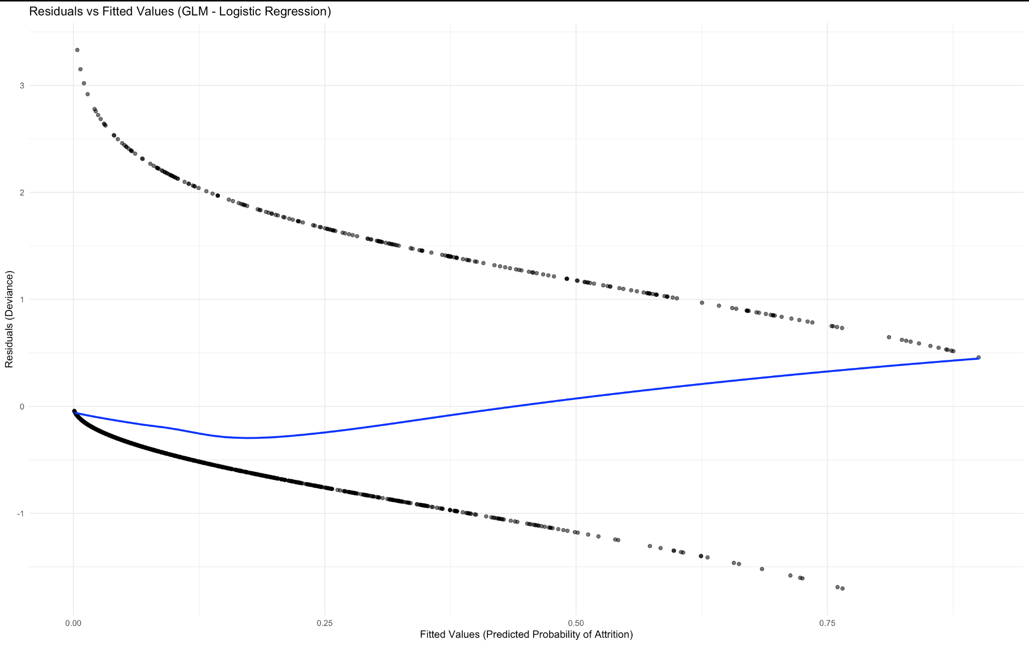
The plot in Figure 2 displays the deviance residuals against the predicted probabilities of attrition and this helps diagnose how well the logistic regression model fits the data and whether key assumptions are being violated. We can see that the residuals form a curved, funnel-shaped pattern as there are two curves above 0 and below 0 as the residuals are constrained by binary outcomes of 0 or 1 representing yes or no of employee attrition.However, the blue LOESS smoothing line is not flat which suggests the model may have some missing nonlinear relationships between predictors. Also, the spread of residuals at higher predicted probabilities tells us less stable model performance for employees with a high likelihood of attrition. But there are no major outliers of assumptions, as the plot suggests that while the model is acceptable, it could be improved by possibly using nonlinear terms or using a more flexible machine learning model.

Figure 3
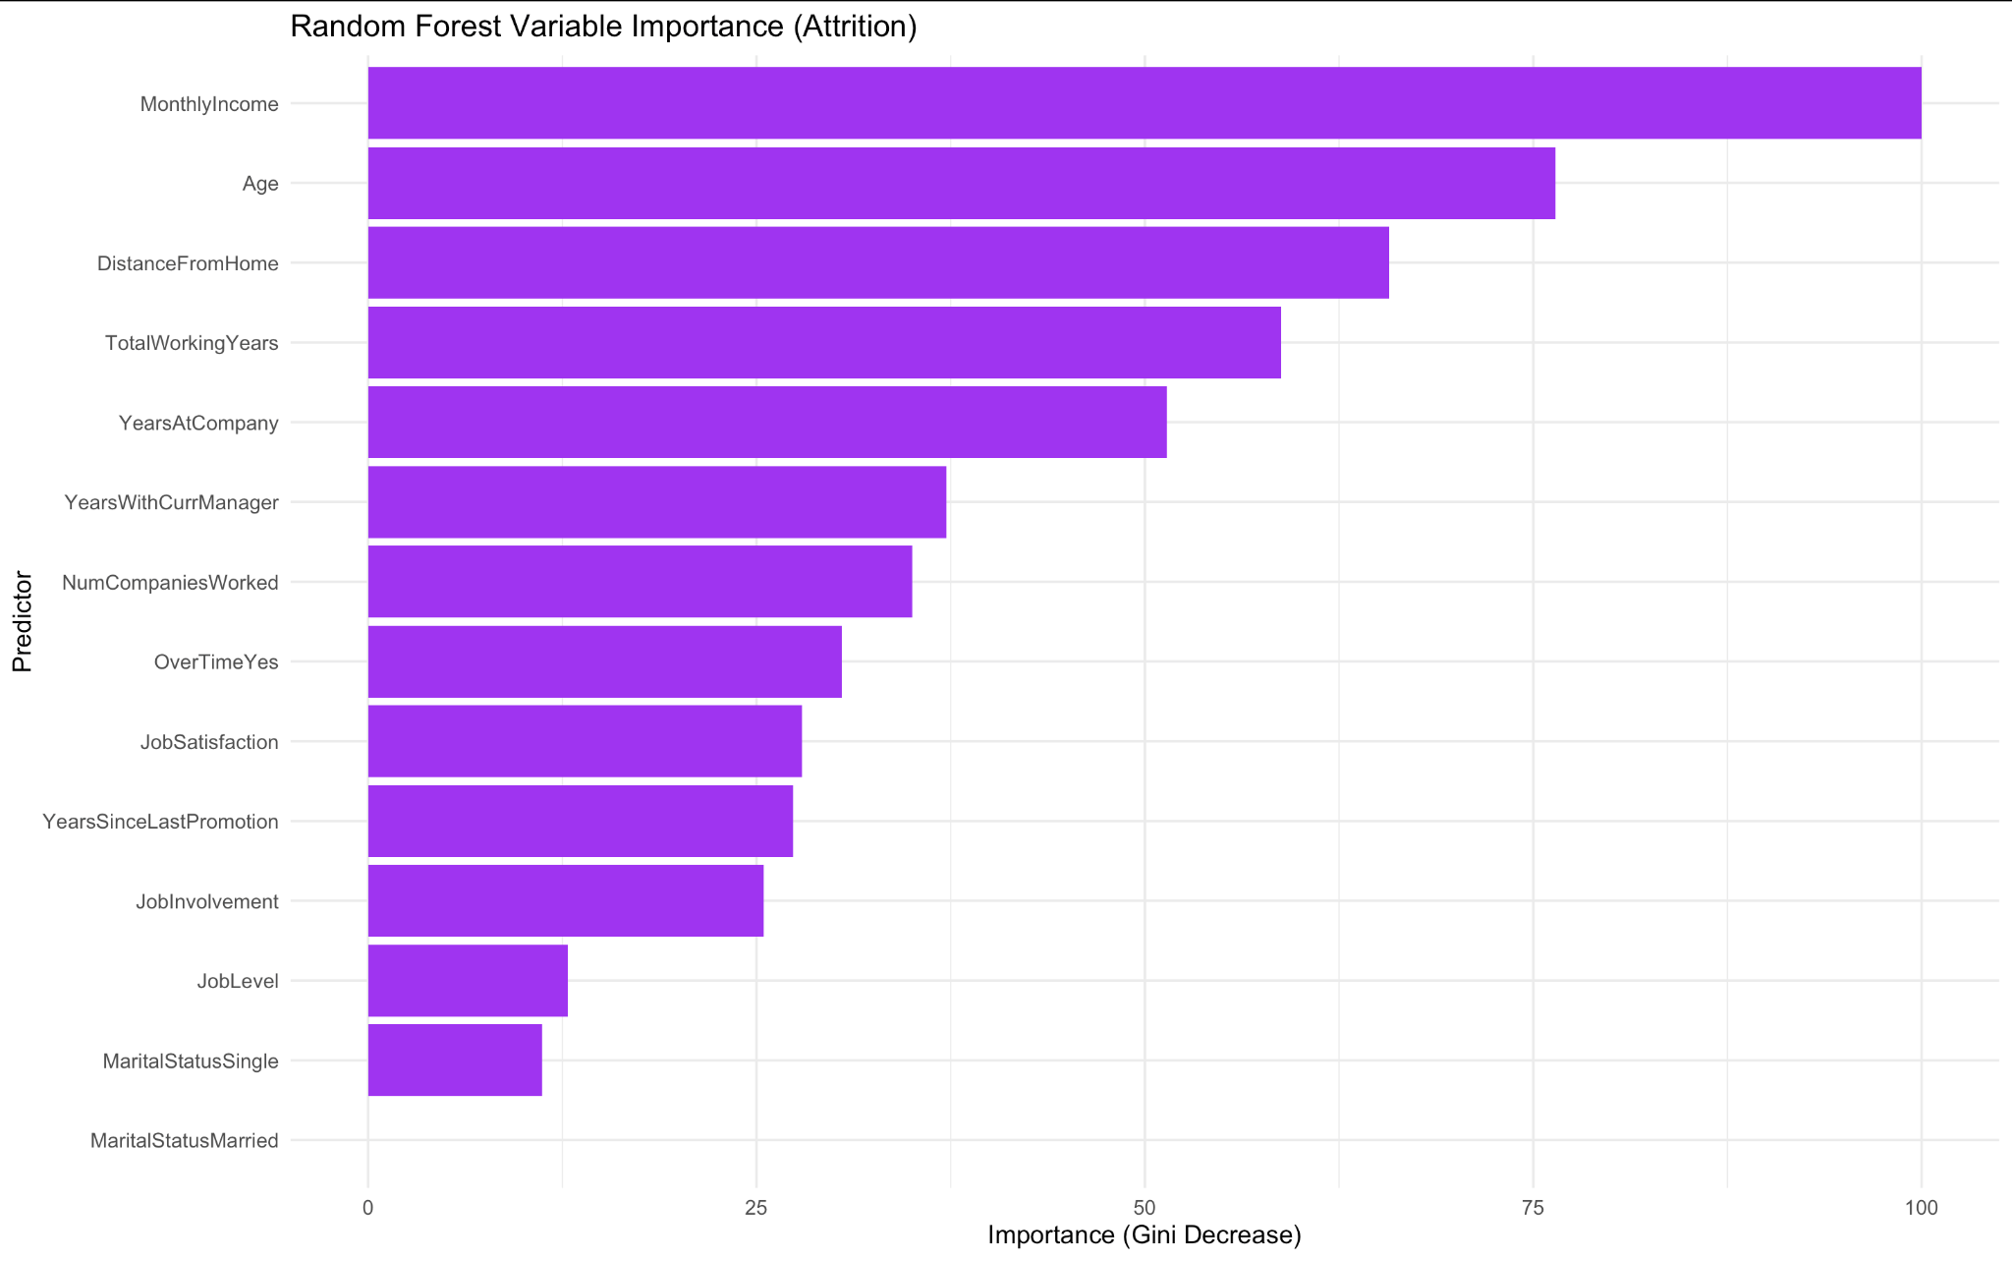
In figure 3, we can see a random forest variable importance plot which shows Monthly Income, Age and Distance From Home as the strongest predictors of employee attrition which means that these factors contribute most to the model’s ability to classify employees likely to leave. Other variables like Total Working Years, Years at Company and Years with Current Manager also play a role which indicates that experience stability in the company influences prediction accuracy. Other variable predictors have moderate to relatively little impact on the model. Overall, the plot highlights that the random forest will rely on Age, Monthly Income and Distance From Home as factors to predict attrition.

Figure 4:
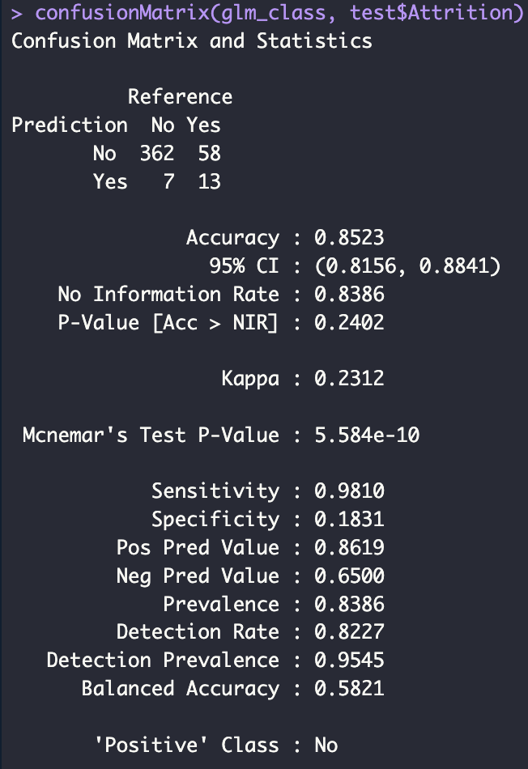
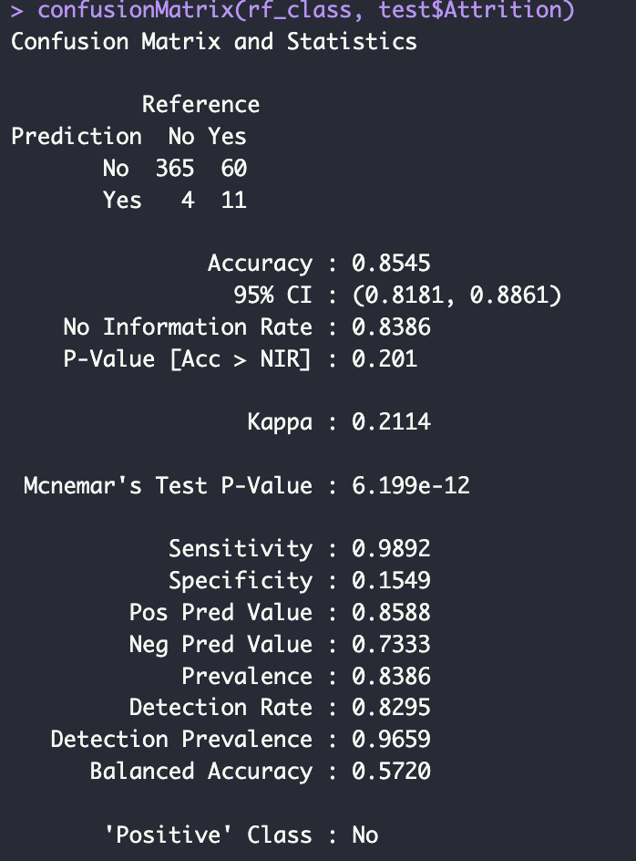

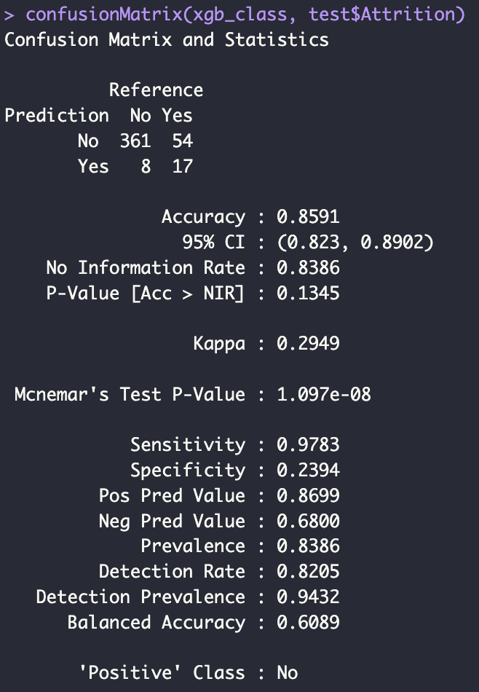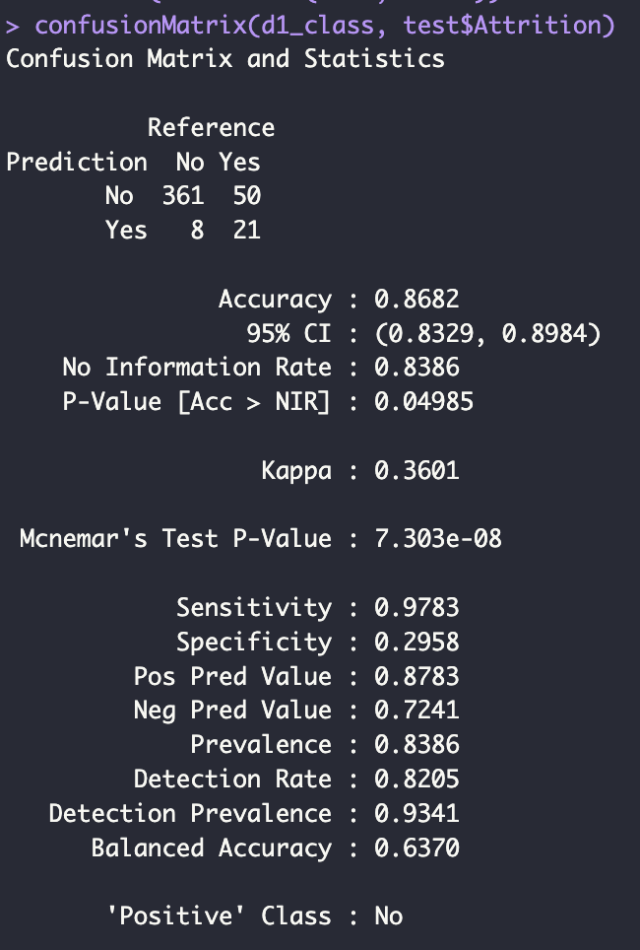

In the above figure 4, we can see the confusion matrices of all 4 models and we can see that accuracy remains high in a range between 85% to 87%. But, this performance is influenced by the dataset’s class imbalance as most employees do not leave the company as the positive class is defined as “No”, all the models achieve very high sensitivity which means the models are good at identifying which employees would stay.
All the models perform poorly at identifying employees who actually leave as reflected by the low specificity which is between 15% to 30% across the models. This means that the models misclassify attrition cases as non-attrition and fail to detect a substantial portion of employees that will leave. XGBoost and the Deep Learning models offer the best gains as these models achieve higher specificity and better balanced accuracy compared to GLM and Random Forest. The Kappa statistic progressively improves from GLM to Random Forest to XGBoost and then to Deep Learning Model and this tells us that the more advanced models provide more meaningful predictive values than simple baseline models.
Overall, the confusion matrices show that while all models appear accurate, they struggle to detect actual attrition cases. Among the models, XGBoost and the Deep Learning model perform best, offering the best improvement in detecting employees who will leave, however the address class imbalance could be addressed directly for the models to get more accurate results.

Figure 5:
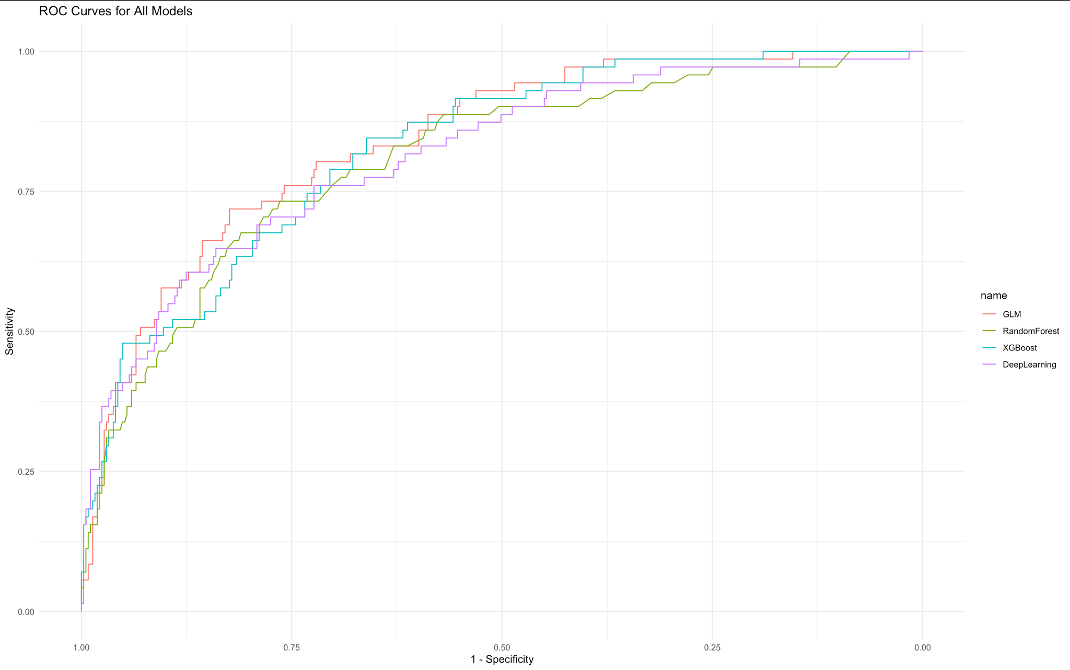

In the figure above, we can see a ROC plot that compares the classification performance of the GLM, Random Forest, XGBoost and Deep Learning models across all possible decision thresholds. All four curves rise above the diagonal line of no discrimination which shows that each model has a meaningful predictive power for attrition. The curves for XGBoost and Deep Learning stays slightly higher than the others across most of the range which indicates stronger overall sensitivity-specificity trade-off. GLM curve performs competitively and at times exceeds the others in the mid region, reflecting its strong ability to distinguish between classes despite being a simpler linear model. The Random Forest curve is slightly below the others which suggests a weaker discrimination which is likely due to struggles with the class imbalance. Overall, the ROC suggests that XGBoost and Deep Learning provide the best predictive performance and this is followed by the GLM model, while Random Forest lags behind. This aligns with the AUC values and this confirms that boosting and neural networks capture more complex patterns that are related to employee attrition.

Figure 6:
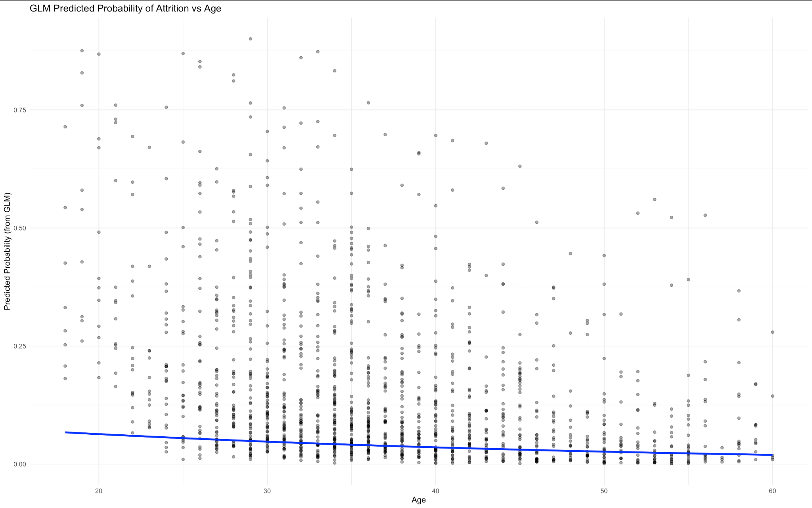
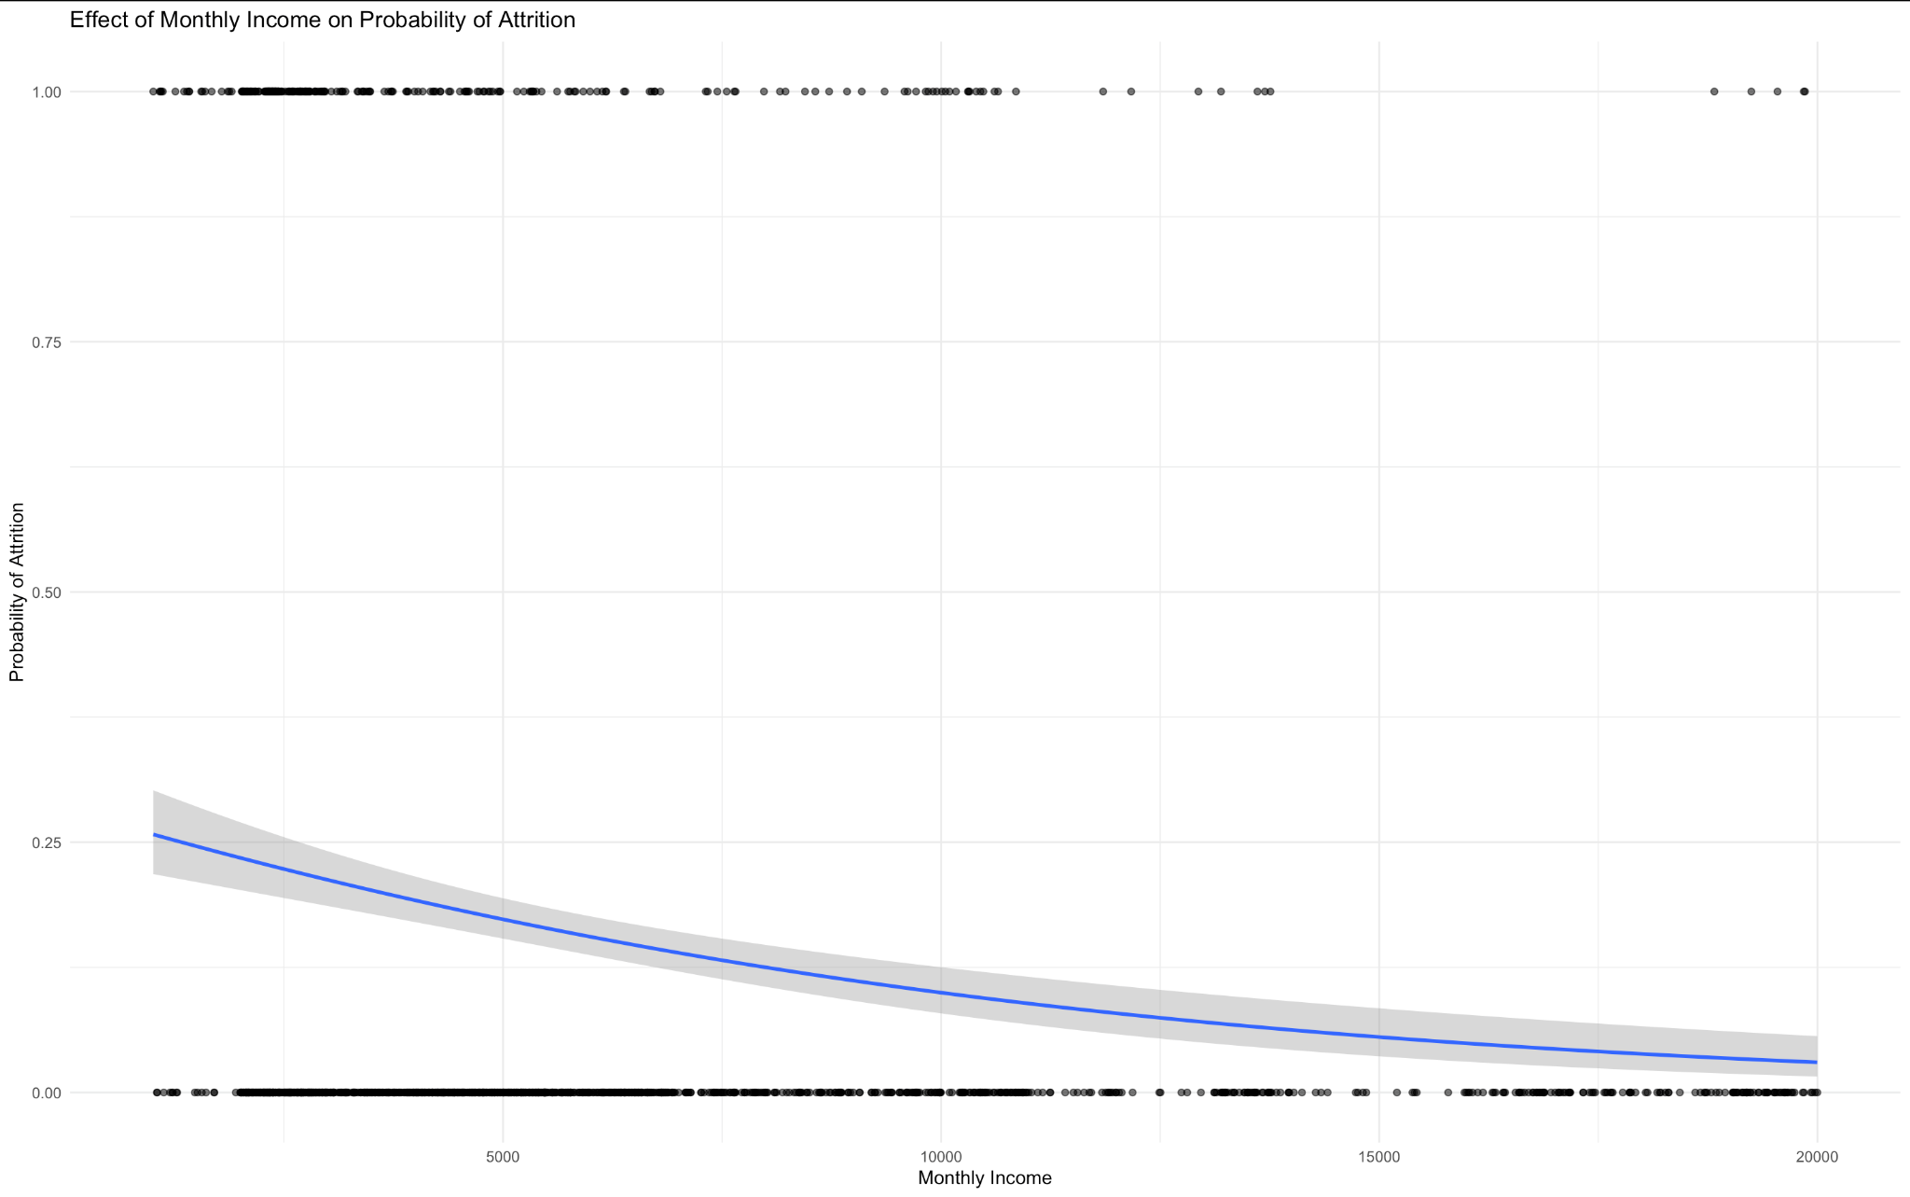
In Figure 6, we can see the first graph shows how the logistic regression model predicts attrition probability across different ages. The overall trend line slopes downward, which indicates that younger employees have a higher predicted probability of leaving, while older employees are less likely to attrition. However individual points are scattered widely, which shows that age alone does not determine attrition as the concentration of higher predicted probabilities among employees from an age range from their 20s all the way to their 50s. The model predicts lower attrition risk as the pattern aligns with typical workforce behaviour, where younger employees tend to be more mobile and more likely to seek new work opportunities.

In the second graph, it shows a strong negative relationship between monthly income and attrition probability. The downward-sloping trend line tells us that employees with lower salaries are more likely to leave, while those with higher incomes have a lower predicted attrition risk. The model suggest a steep decline in attrition probability as income rises from low to moderate levels, the effect flattening at higher salary ranges. We can see that the pattern is intuitive as better-paid employees are generally more satisfied and feel more valued and have few financial incentives to leave. At high levels of income, we can see that the attrition probability pretty much reaches to zero which shows that salary is one of the strongest predictors of employee retention in the dataset.

Figure 7:
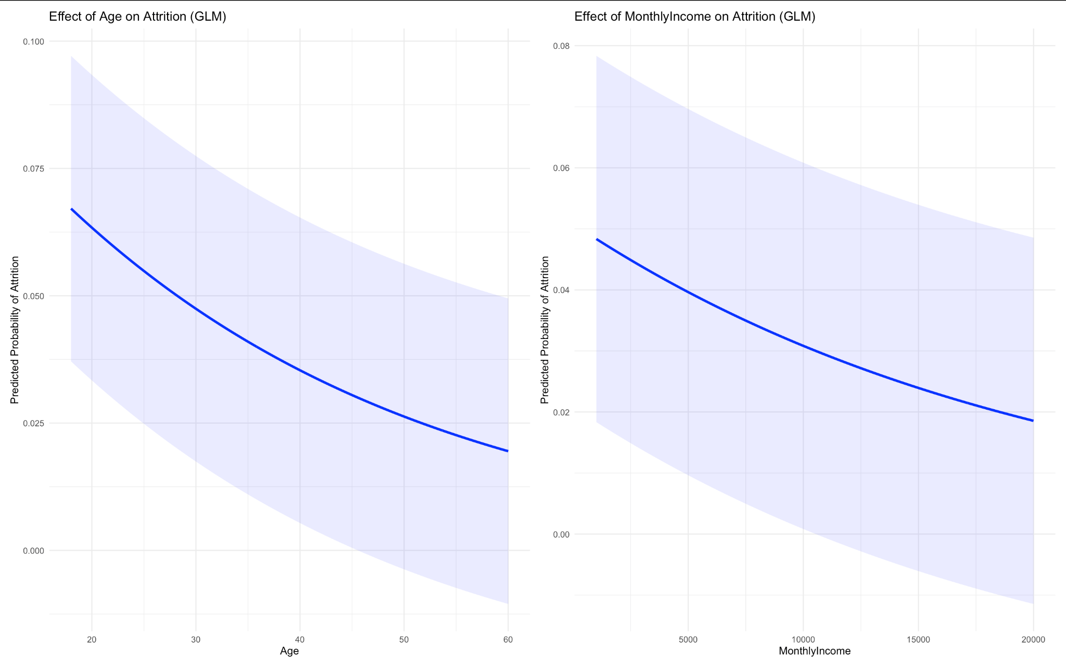
Here is a GLM plot which shows both age and monthly income side by side, we can see both have a strong negative relationship with attrition risk suggesting that younger and lower-paid employees are more likely to leave, while attrition probability declines as employees get older or earn higher salaries. This decline is steepest near the early ages and lower income levels, and then we see the decline flattening at higher values which shows us the diminishing effects. We can see that the wider confidence bands at the extremes suggests a greater uncertainty where the data is sparse.

Figure 8:
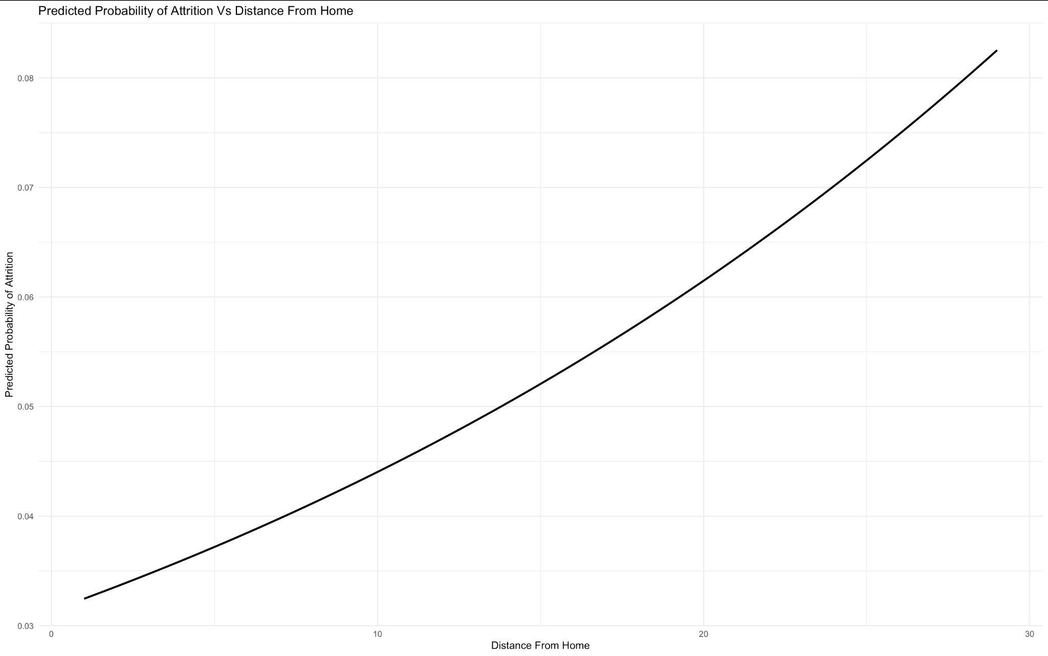
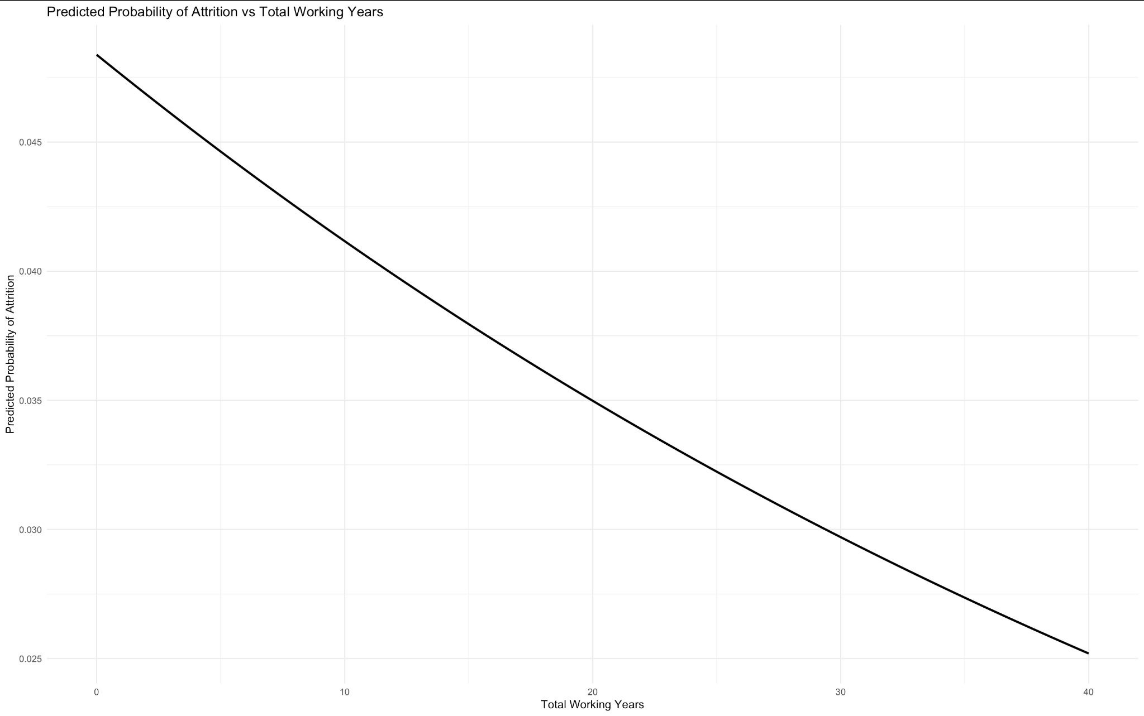
In the above figure, we can see in the first graph shows a strong positive relationship between commute distance and predicted probability of attrition. We can see as distance from home increases, the model predicts the steady rising likelihood that an employee will leave the organisation and this upward trend suggests that employees with longer commutes are more likely to experience dissatisfaction or a reduced work-life balance due due commutes being longer which contributes to a higher risk of turnover. Even though the absolute probabilities remain low, there is the consistent increase that indicates that commute distance is an important attrition driver in the model.
In the second graph, we can see the opposite pattern occurring as attrition probability decreases as total years of work experience increases. This tells us that employees with fewer years of total experience have a higher likelihood of leaving, compared to those with long established careers show a sharp reduction in attrition risk. This downward trend suggests that more experienced employees tend to have a more stable and invested environment so they are less likely to leave their job.
Figure 9: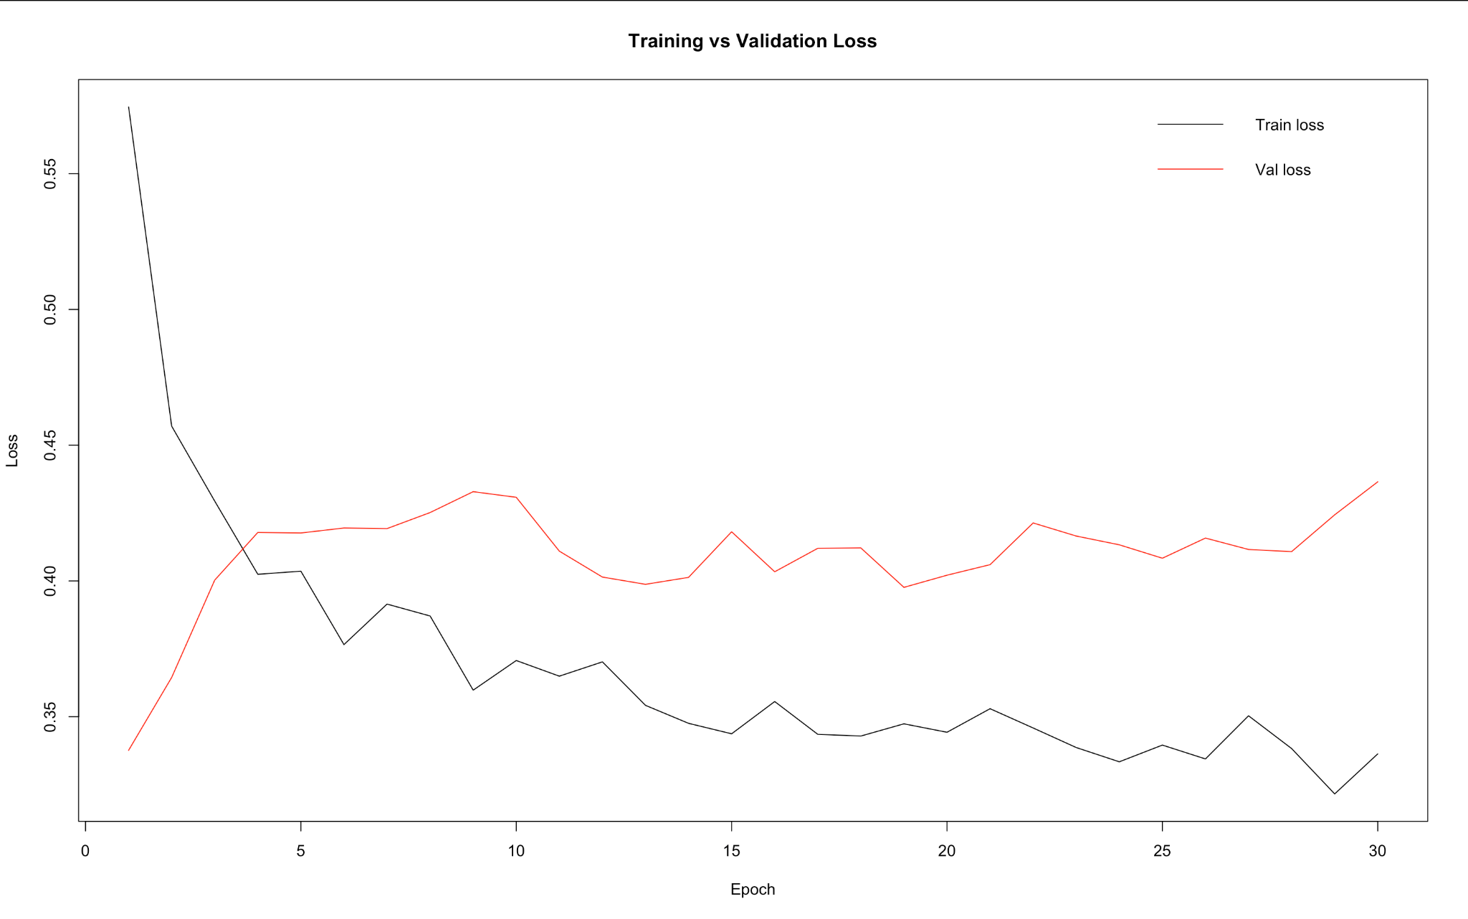
In the final Figure above, we can see a graph of Training vs Validation Loss and its shows the model’s training loss steadily decreases over the 30 epochs and this tells us that the neural network is learning the pattern in the training data. However, the validation loss stops decreasing early and levels off and then it fluctuates with an upward trend. We can see this widening gap between the training and the validation loss which suggests that the model begins to overfit after the first couple of epochs and that learning the training data too closely and failing to generalise to unseen data. The validation loss curve’s instability indicates that the model is sensitive to noise in the validation set or that it could lack regularisation strength. As we can see that the graph is overfitting, the model continues improving on the training data while generalisation performance stagnates or worsens which implies that training should be stopped earlier. By using early stopping, we could reduce model complexity, increase dropout or add regularisation which therefore would achieve a better predictive performance.

- Conclusion

In this analysis, we are provided with a comprehensive examination of key factors that influence employee attrition using multiple modelling approaches which include logistic regression, Random Forest, XGBoost and Deep Learning. Across all the models and visualisations, there is a consistent pattern that emerges that is that younger employees, lower-income employees, those with longer commutes and those working overtime are significantly more likely to leave the organisation, while factors such as age, job satisfaction, tenure and longer relationships with managers help reduce turnover risk. The logistic regression model offered a clear interpretability and highlighted the most influential predictor, while the Random Forest importance plot reinforced the central role of income, age and commute distance in attrition prediction.
Model performance metrics show us that although all models achieve high overall accuracy, this was driven by the imbalance within the attrition outcomes. With more advanced models like XGBoost and Deep Learning models - it shows improved ability to detect true attrition cases, offering higher specificity and stronger overall discrimination as seen in ROC curves and Kappa values. However, the Deep Learning training curves show us that there is some overfitting, which suggests the need for improvement and for early stopping.

In conclusion, the findings tell us that employee attrition is shaped by both personal and workplace factors which include Monthly Income, years at the job, job involvement and work-life balance. While machine learning models enhance predictive capability especially for complex patterns, addressing class imbalance and refining the model would further improve accuracy and the usefulness.

- Appendix

# Load necessary libraries
library(tidyverse)
library(patchwork)
library(caret)
library(randomForest)
library(xgboost)
library(pROC)
library(keras)

# Load and prepare dataset
df <- read.csv("Final dataset Attrition.csv", stringsAsFactors = TRUE)

# Ensure the target variable is a factor which is Attrition and set to "No" as a reference level
df$Attrition <- as.factor(df$Attrition)
df$Attrition <- relevel(df$Attrition, ref = "No")

#Check on Target variables
str(df$Attrition)
table(df$Attrition)

# Fit GLM (logistic regression) model
glm_model_full <- glm(
Attrition ~ Age + DistanceFromHome +
JobInvolvement + JobLevel + JobSatisfaction + MaritalStatus + MonthlyIncome +
NumCompaniesWorked + OverTime + TotalWorkingYears + YearsAtCompany +
YearsSinceLastPromotion + YearsWithCurrManager,
data = df,
family = binomial(link = "logit")
)

# Summary of the model
summary(glm_model_full)

# Extract fitted values and residuals
df$fitted <- fitted(glm_model_full)
df$residuals <- residuals(glm_model_full, type = "deviance")

# Plot Residuals vs Fitted
ggplot(df, aes(x = fitted, y = residuals)) +
geom_point(alpha = 0.6) +
geom_smooth(method = "loess", se = FALSE, color = "blue") +
labs(
title = "Residuals vs Fitted Values (GLM - Logistic Regression)",
x = "Fitted Values (Predicted Probability of Attrition)",
y = "Residuals (Deviance)"
) +
theme_minimal()

#Effect of Age on predicted Attrition(GLM)
x_var <- "Age"
#Creates a sequence of Age values across its range
x_seq <- seq(min(df[[x_var]], na.rm = TRUE),
max(df[[x_var]], na.rm = TRUE),
length.out = 300)
#Builds a profile with medians of common categorises
newdata <- df %>%
summarise(
DistanceFromHome = median(DistanceFromHome, na.rm = TRUE),
JobInvolvement = median(JobInvolvement, na.rm = TRUE),
JobLevel = median(JobLevel, na.rm = TRUE),
JobSatisfaction = median(JobSatisfaction, na.rm = TRUE),
MaritalStatus = names(sort(table(MaritalStatus), decreasing = TRUE))[1],
MonthlyIncome = median(MonthlyIncome, na.rm = TRUE),
NumCompaniesWorked = median(NumCompaniesWorked, na.rm = TRUE),
OverTime = names(sort(table(OverTime),decreasing = TRUE))[1],
TotalWorkingYears = median(TotalWorkingYears, na.rm = TRUE),
YearsAtCompany = median(YearsAtCompany, na.rm = TRUE),
YearsSinceLastPromotion = median(YearsSinceLastPromotion, na.rm = TRUE),
YearsWithCurrManager = median(YearsWithCurrManager, na.rm = TRUE)
) %>%
slice(rep(1,length(x_seq))) %>%
mutate(!!x_var := x_seq)
#Stores predicted probabilities of attrition for each Age value
newdata$pred_prob <- predict(glm_model, newdata = newdata, type = "response")

#Plots fitted probabilities against Age
ggplot() +
geom_point(data = df, aes_string(x = x_var, y = "fitted"),
alpha = 0.4, color = "black") +
geom_line(data = newdata, aes_string(x = x_var, y = "pred_prob"),
color = "blue", size = 1.2) +
labs(
title = paste("GLM Predicted Probability of Attrition vs", x_var),
x = x_var,
y = "Predicted Probability (from GLM)"
) +
theme_minimal()

#Effect of Monthly Income

#Converts Attrition to 0/1 to be set up for plotting
df$Attrition01 <- ifelse(df$Attrition == "Yes", 1, 0)

ggplot(df, aes(x = MonthlyIncome, y = Attrition01)) +
geom_point(alpha = 0.6) +
geom_smooth(
method = "glm",
method.args = list(family = binomial(link = "logit")),
se = TRUE
) +
scale_y_continuous(limits = c(0,1)) +
labs(
title = "Effect of Monthly Income on Probability of Attrition",
x = "Monthly Income",
y = "Probability of Attrition"
) +
theme_minimal()

#Effect of Distance from Home
#Sequence of Distances
dist_seq <- seq(min(df$DistanceFromHome),
max(df$DistanceFromHome),
length.out = 100)

#Build employee and vary DistanceFromHome
new_dist <- data.frame(
DistanceFromHome = dist_seq,
TotalWorkingYears = median(df$TotalWorkingYears, na.rm = TRUE),
Age = median(df$Age, na.rm = TRUE),
JobInvolvement = median(df$JobInvolvement, na.rm = TRUE),
JobLevel = median(df$JobLevel, na.rm = TRUE),
JobSatisfaction = median(df$JobSatisfaction, na.rm = TRUE),
MaritalStatus = names(sort(table(df$MaritalStatus), decreasing = TRUE))[1],
MonthlyIncome = median(df$MonthlyIncome, na.rm = TRUE),
NumCompaniesWorked = median(df$NumCompaniesWorked, na.rm = TRUE),
OverTime = names(sort(table(df$OverTime), decreasing = TRUE))[1],
YearsAtCompany = median(df$YearsAtCompany, na.rm = TRUE),
YearsSinceLastPromotion = median(df$YearsSinceLastPromotion, na.rm = TRUE),
YearsWithCurrManager = median(df$YearsWithCurrManager, na.rm = TRUE)
)

#Predicted Probability vs DistanceFromHome
new_dist$pred_prob <- predict(glm_model_full, newdata = new_dist, type = "response")

ggplot(new_dist, aes(x = DistanceFromHome, y = pred_prob)) +
geom_line(size = 1) +
labs(
title = "Predicted Probability of Attrition Vs Distance From Home",
x = "Distance From Home",
y = "Predicted Probability of Attrition"
) +
theme_minimal()

#Effect of Total Working Years
twy_seq <- seq(min(df$TotalWorkingYears),
max(df$TotalWorkingYears),
length.out = 100)

new_twy <- new_dist
new_twy$TotalWorkingYears <- twy_seq

new_twy$pred_prob<- predict(glm_model_full, newdata = new_twy, type = "response")

ggplot( new_twy, aes(x = TotalWorkingYears, y = pred_prob)) +
geom_line(size = 1) +
labs(
title = "Predicted Probability of Attrition vs Total Working Years",
x = "Total Working Years",
y = "Predicted Probability of Attrition"
) +
theme_minimal()

# GLM Curve function that plots both age and monthly income
glm_curve <- function(var){

x_seq <- seq(
min(df[[var]], na.rm = TRUE),
max(df[[var]], na.rm = TRUE),
length.out = 300
)

base <- df %>%
summarise(
Age = median(Age),
DistanceFromHome = median(DistanceFromHome),
JobInvolvement = median(JobInvolvement),
JobLevel = median(JobLevel),
JobSatisfaction = median(JobSatisfaction),
MaritalStatus = names(sort(table(MaritalStatus), decreasing = TRUE))[1],
MonthlyIncome = median(MonthlyIncome),
NumCompaniesWorked = median(NumCompaniesWorked),
OverTime = names(sort(table(OverTime), decreasing = TRUE))[1],
TotalWorkingYears = median(TotalWorkingYears),
YearsAtCompany = median(YearsAtCompany),
YearsSinceLastPromotion = median(YearsSinceLastPromotion),
YearsWithCurrManager = median(YearsWithCurrManager)
)
newdata <- base[rep(1, length(x_seq)), ]
newdata[[var]] <- x_seq

newdata$pred <- predict(glm_model, newdata, type = "response")

ggplot(newdata, aes(x = .data[[var]], y = pred)) +
geom_line(color = "blue", size = 1.2) +
geom_ribbon(aes(ymin = pred -0.03, ymax = pred + 0.03),
alpha = 0.1, fill = "blue") +
labs(
title = paste("Effect of", var, "on Attrition (GLM)"),
x = var,
y = "Predicted Probability of Attrition"
) +
theme_minimal()
}

p_age <- glm_curve("Age")
p_income <- glm_curve("MonthlyIncome")

p_age + p_income

#Train/ test split for machine learning models
set.seed(123)
idx <- createDataPartition(df$Attrition, p = 0.7, list = FALSE)
train <- df[idx, ]
test <- df[-idx, ]

#Sets up cross-validation control
ctrl <- trainControl(
method = "repeatedcv",
number = 5,
repeats = 2,
classProbs = TRUE,
summaryFunction = twoClassSummary,
savePredictions = "final"
)

#GLM
set.seed(123)
glm_fit <- train (
Attrition ~ Age + DistanceFromHome + JobInvolvement + JobLevel +
JobSatisfaction + MaritalStatus + MonthlyIncome +
NumCompaniesWorked + OverTime + TotalWorkingYears +
YearsAtCompany + YearsSinceLastPromotion + YearsWithCurrManager,
data = train,
method = "glm",
family = binomial,
metric = "ROC",
trControl = ctrl
)

glm.fit

glm_prob <- predict(glm_fit, newdata = test, type = "prob")[, "Yes"]
glm_class <- ifelse(glm_prob > 0.5, "Yes", "No") %>% factor(levels = c("No", "Yes"))

confusionMatrix(glm_class, test$Attrition)
roc_glm <- roc(test$Attrition, glm_prob); auc(roc_glm)

# Random Forest Model
set.seed(123)
rf_fit <- train(
Attrition ~ Age + DistanceFromHome + JobInvolvement + JobLevel +
JobSatisfaction + MaritalStatus + MonthlyIncome +
NumCompaniesWorked + OverTime + TotalWorkingYears +
YearsAtCompany + YearsSinceLastPromotion + YearsWithCurrManager,
data = train,
method = "rf",
metric = "ROC",
trControl = ctrl
)

rf_fit

rf_imp <- varImp(rf_fit)$importance

rf_imp_df <- rf_imp %>%
rownames_to_column(var = "Variable") %>%
arrange(desc(Overall))

print(rf_imp_df)

#Plots variable importance
ggplot(rf_imp_df, aes(x = reorder(Variable, Overall), y = Overall)) +
geom_bar(stat = "identity", fill = "purple") +
coord_flip() +
labs(
title = "Random Forest Variable Importance (Attrition)",
x = "Predictor",
y = "Importance (Gini Decrease)"
) +
theme_minimal(base_size = 14)

rf_prob <- predict(rf_fit, newdata = test, type = "prob")[, "Yes"]
rf_class <- ifelse(rf_prob > 0.5, "Yes", "No") %>% factor(levels = c("No", "Yes"))

confusionMatrix(rf_class, test$Attrition)
roc_rf <- roc(test$Attrition, rf_prob); auc(roc_rf)

#XGBoost Model
set.seed(123)

xgb_fit <- train(
Attrition ~ Age + DistanceFromHome + JobInvolvement + JobLevel +
JobSatisfaction + MaritalStatus + MonthlyIncome +
NumCompaniesWorked + OverTime + TotalWorkingYears +
YearsAtCompany + YearsSinceLastPromotion + YearsWithCurrManager,
data = train,
method = "xgbTree",
metric = "ROC",
trControl = ctrl
)

xgb_fit

xgb_prob <- predict(xgb_fit, newdata = test, type = "prob")[, "Yes"]
xgb_class <- ifelse(xgb_prob > 0.5, "Yes", "No") %>% factor(levels = c("No", "Yes"))

confusionMatrix(xgb_class, test$Attrition)
roc_xgb <- roc(test$Attrition, xgb_prob); auc(roc_xgb)

#Deep Learning model via Keras Neural Network
#Prepares design matrices for Keras
x_train <- model.matrix(Attrition ~ Age + DistanceFromHome + JobInvolvement +
JobLevel + JobSatisfaction + MaritalStatus +
MonthlyIncome + NumCompaniesWorked + OverTime +
TotalWorkingYears + YearsAtCompany +
YearsSinceLastPromotion + YearsWithCurrManager,
data = train)[, -1]

x_test <- model.matrix(Attrition ~ Age + DistanceFromHome + JobInvolvement +
JobLevel + JobSatisfaction + MaritalStatus +
MonthlyIncome + NumCompaniesWorked + OverTime +
TotalWorkingYears + YearsAtCompany +
YearsSinceLastPromotion + YearsWithCurrManager,
data = test)[, -1]

#Binary targets for Keras
y_train <- ifelse(train$Attrition == "Yes", 1, 0)
y_test <- ifelse(test$Attirtion == "Yes", 1, 0)

#Standardise predictors
x_train <- scale(x_train)
x_test <- scale(x_test,
center = attr(x_train, "scaled:center"),
scale = attr(x_train, "scaled:scale"))

input_dim <- ncol(x_train)

#Defines neural network architecture
keras_model <- keras_model_sequential() %>%
layer_dense(units = 64, activation = "relu", input_shape = input_dim) %>%
layer_dropout(rate = 0.3) %>%
layer_dense(units = 32, activation = "relu") %>%
layer_dropout(rate = 0.3) %>%
layer_dense(units = 1, activation = "sigmoid")

#Compiles model
keras_model %>% compile(
loss = "binary_crossentropy",
optimizer = optimizer_adam(learning_rate = 0.001),
metrics = c("accuracy")
)

#Train neural network
history <- keras_model %>% fit(
x = x_train, y = y_train,
epochs = 30,
batch_size = 32,
validation_split = 0.1,
verbose = 0
)

#Plots training vs validation loss to check for overfitting
plot(history$metrics$loss, type = "l",
xlab= "Epoch", ylab = "Loss", main = "Training vs Validation Loss")
lines(history$metrics$val_loss, col = "red")
legend("topright", legend = c("Train loss", "Val loss"),
col = c("black", "red"), lty = 1, bty = "n")

#Predictions and perfromance on test data set
d1_prob <- keras_model %>% predict(x_test) %>% as.vector()
d1_class <- ifelse(d1_prob > 0.5, "Yes", "No") %>%
factor(levels = c("No", "Yes"))

confusionMatrix(d1_class, test$Attrition)
roc_d1 <- roc(test$Attrition, d1_prob); auc(roc_d1)

#Compares models by AUC on a ROC curve plot
data.frame(
Model = c("GLM", "Random Forest", "XGBoost","Deep Learning"),
AUC = c(auc(roc_glm), auc(roc_rf), auc(roc_xgb), auc(roc_d1))
) %>%
arrange(desc(AUC))

roc_list <- list(
GLM = roc_glm,
RandomForest = roc_rf,
XGBoost = roc_xgb,
DeepLearning = roc_d1
)

ggroc(roc_list) +
labs(
title = "ROC Curves for All Models",
x = "1 - Specificity",
y = "Sensitivity"
) +
theme_minimal()

